IMPORTANT REMINDER - In order for your application to be considered for this award, you must submit your application to the Financial Aid Office with ALL of the additional documentation by the announced deadline. Late or incomplete applications will not be considered. Pay attention to details.

Scholarship Objectives

- Recognize and reward the academic excellence of ministerial students who choose to enroll in the Biblical Studies program at Southwestern Christian College.

- Assist recipients in meeting their financial needs as they pursue higher Christian education.

Minimum Personal and Academic Requirements for Consideration and/or Award
- Active and faithful membership in the Church of Christ.

- Demonstration of Christian character and lifestyle.

- Proof of enrollment at Southwestern Christian College during the semester of application.

- Maintain a minimum cumulative GPA of 2.5 and full-time status at SwCC. (minimum cumulative GPA of 2.5 required for incoming students from another college)

Minimum Requirements for Application

- Complete a scholarship application in its entirety.

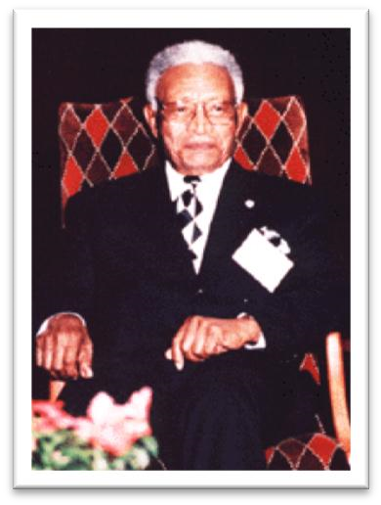
- Submit an autobiography (including future aspirations in ministry) along with a recent 3x5 photo. This autobiography must be approximately one (1) double-spaced type-written page in length.

- Submit a biography of Dr. J.S. Winston, Sr. This biography must be approximately one (1) double-spaced type-written page in length.

- Submit three (3) typed letters of reference. These letters must include the contact information of your reference.

Personal Information
First Name: _____________ Middle Initial: ___ Last Name: _______________
Address: ____________________ City: __________ State: ____ Zip: ______ Phone: ___________ Alt. Phone: __________ e-mail: ____________________
- Marital Status: Married ___ Separated ___ Single ___ Divorced ___
- What areas of ministry are you interested in? (ex. family, music, youth, etc.)
______________________________________________________________
- Have you committed to earning the Bachelor of Science in Religious Studies from
Southwestern Christian College? Yes ___ No ___ Undecided ___
- What other financial assistance are you applying for this semester? Check all that apply. Private Loan(s) ___ TEG ___ SEOG ___ SwCC Work Study ____
Government Grant(s) ___ Federal Loan(s) ___ Other ___
- What other financial assistance will you have?
______________________________________________________________
- Current GPA (if returning to SwCC): ___ Are you on any form of suspension? ____

Family Information
Spouse Name: ___________________________ Age: ____ Relationship: _______
Dependents Name: ________________________ Age: ____ Relationship: _______
Dependents Name: ________________________ Age: ____ Relationship: _______
Dependents Name: ________________________ Age: ____ Relationship:_______

Family References (required)
Name: _____________________ Relationship: _________ Phone: ___________ Name: _____________________ Relationship: _________ Phone: ___________ Academic Information
High School Name: ________________ Address: _______________________
Graduation Date: ______________ GPA: ____
Other Schools or Colleges Attended
- School Name: ____________________ Address: ______________________
Graduation Date: _______________ Major: ___________________ GPA: ____
- School Name: ____________________ Address: ________________________
Graduation Date: _______________ Major: ___________________ GPA: ____
- School Name: ____________________ Address: ________________________
Graduation Date: _______________ Major: ___________________ GPA: ____

Church Affiliation
How long have you been a member of the Church of Christ? ______
Home Congregation: _________________________ Minister: ______________
Address: ___________________________________ Phone: ______________
Length of Membership at Congregation: ________ Ministry Involvement at Congregation:
_________________________________________________________________
_________________________________________________________________
I have read, complied and agreed to all of the requirements and stipulations regarding this scholarship. I have completed this application process in good faith and have only submitted information and documentation that is accurate to my knowledge.

Printed Name: ________________ Signature: _________________ Date: _______

In the event that I am awarded a scholarship from the J.S. Winston Sound Doctrine Foundation, I agree to financially support the foundation following my departure from Southwestern Christian College.

Printed Name: ________________ Signature: _________________ Date: _______

FOR OFFICE USE ONLY
Date Received: _______ Approved: __ Declined: __ Reason: _________________________
Signature: _____________________ Date Reviewed: _________ Award Amount: _________

J. S. WINSTON SOUND DOCTRINE FOUNDATION
P O BOX 763503
DALLAS, TEXAS 75376-3503
PHONE:972.333.3323
Website: jswinstonsdf.org
Email: jswinstonsdf@yahoo.com

